**Submitted To:**

**Miss Saba Ramzan**

**Team Members:**

1. Yusra Noor (SU92-BSCSM-S23-79)
2. Faraz Ahmad (SU92-BSCSM-S23-117)

**Database Project Proposal:**

“Global Supply Chain Management System”

Developing a comprehensive database system for managing the global supply chain lifecycle. This system will track product sourcing, suppliers, logistics, inventory, distribution, and customer demand on a global scale. The database will manage data for multiple stakeholders, including suppliers, manufacturers, logistics providers, warehouses, and customers across different regions.

**Goals:**

* **Efficient Data Tracking:** Enable real-time tracking of supply chain elements, including suppliers, logistics, inventory levels, and shipments.
* **Scalability:** Design a database that can support high data volumes from global transactions and users.
* **Security and Data Integrity:** Implement data controls and auditing for secure and accurate data storage and processing.
* **Insights and Reporting:** Provide business intelligence and analytics capabilities to support strategic decision-making.

**Tables:**

1. **Supplier Management**

* **Suppliers**
  + supplier_id (PK)
  + name
  + contact_name
  + email
  + phone
  + country
  + address
  + rating
  + status (active, inactive)
* **Supplier Contracts**
  + contract_id (PK)
  + supplier_id (FK, references Suppliers)
  + start_date
  + end_date
  + contract_details
  + terms
  + status (active, expired, terminated)
* **Supplier Products**
  + supplier_product_id (PK)
  + supplier_id (FK, references Suppliers)
  + product_id (FK, references Products)
  + cost
  + delivery_lead_time (in days)

**2. Product Management**

* **Products**
  + product_id (PK)
  + name
  + description
  + category_id (FK, references Product Categories)
  + weight
  + dimensions (length, width, height)
  + base_price
  + status (active, discontinued)
* **Product Categories**
  + category_id (PK)
  + category_name
  + parent_category_id (FK, references Product Categories)
  + description
* **Product SKUs (Stock Keeping Units)**
  + sku_id (PK)
  + product_id (FK, references Products)
  + variant_name (e.g., size, color)
  + sku_code
  + barcode
  + cost_price
  + status (active, inactive)

**3. Inventory Management**

* **Warehouses**
  + warehouse_id (PK)
  + name
  + location
  + capacity
  + manager_id (FK, references Employees)
* **Warehouse Inventory**
  + inventory_id (PK)
  + warehouse_id (FK, references Warehouses)
  + product_id (FK, references Products)
  + sku_id (FK, references Product SKUs)
  + quantity
  + reorder_level
  + last_restock_date
* **Inventory Movements**
  + movement_id (PK)
  + inventory_id (FK, references Warehouse Inventory)
  + quantity
  + movement_type (addition, removal, adjustment)
  + movement_date
  + reason

**4. Order Management**

* **Customers**
  + customer_id (PK)
  + name
  + email
  + phone
  + billing_address
  + shipping_address
  + customer_type (business, individual)
* **Orders**
  + order_id (PK)
  + customer_id (FK, references Customers)
  + order_date
  + status (pending, confirmed, shipped, delivered, canceled)
  + total_amount
* **Order Items**
  + order_item_id (PK)
  + order_id (FK, references Orders)
  + product_id (FK, references Products)
  + sku_id (FK, references Product SKUs)
  + quantity
  + unit_price
  + discount
  + total_price
* **Order Shipments**
  + shipment_id (PK)
  + order_id (FK, references Orders)
  + shipment_date
  + expected_delivery_date
  + tracking_number
  + carrier_id (FK, references Carriers)
  + status (in transit, delivered, delayed)

**5. Logistics and Transportation**

* **Carriers**
  + carrier_id (PK)
  + name
  + contact_info
  + country
  + delivery_areas
  + service_type (air, sea, ground)
  + rating
* **Shipments**
  + shipment_id (PK)
  + carrier_id (FK, references Carriers)
  + shipment_type (inbound, outbound)
  + origin
  + destination
  + departure_date
  + estimated_arrival_date
  + actual_arrival_date
  + status (in transit, delivered, delayed)
* **Shipment Items**
  + shipment_item_id (PK)
  + shipment_id (FK, references Shipments)
  + order_item_id (FK, references Order Items)
  + quantity

**6. Human Resources**

* **Employees**
  + employee_id (PK)
  + first_name
  + last_name
  + email
  + phone
  + department_id (FK, references Departments)
  + position
  + hire_date
  + status (active, terminated, on leave)
* **Departments**
  + department_id (PK)
  + name
  + manager_id (FK, references Employees)
  + location

**7. Payment and Accounting**

* **Invoices**
  + invoice_id (PK)
  + order_id (FK, references Orders)
  + invoice_date
  + due_date
  + amount_due
  + status (paid, unpaid, overdue)
* **Payments**
  + payment_id (PK)
  + invoice_id (FK, references Invoices)
  + payment_date
  + amount
  + payment_method (credit card, bank transfer, etc.)

**8. Analytics and Reporting**

* **Supplier Performance Metrics**
  + supplier_id (FK, references Suppliers)
  + metric_date
  + on_time_delivery_rate
  + quality_score
  + cost_efficiency
* **Order Fulfillment Metrics**
  + order_id (FK, references Orders)
  + fulfillment_date
  + lead_time
  + order_accuracy_rate
  + return_rate
* **Inventory Turnover Metrics**
  + product_id (FK, references Products)
  + warehouse_id (FK, references Warehouses)
  + turnover_rate
  + period_start
  + period_end

**9. System Security and Auditing**

* **Users**
  + user_id (PK)
  + username
  + password_hash
  + role (admin, manager, staff)
  + last_login
  + status (active, disabled)
* **Audit Logs**
  + log_id (PK)
  + user_id (FK, references Users)
  + action (create, update, delete)
  + table_name
  + record_id
  + timestamp
  + description

**ERD Diagram:**

The ERD Diagram for this database will be provided along with this file, you can find it attached!

**Create Table Queries:**

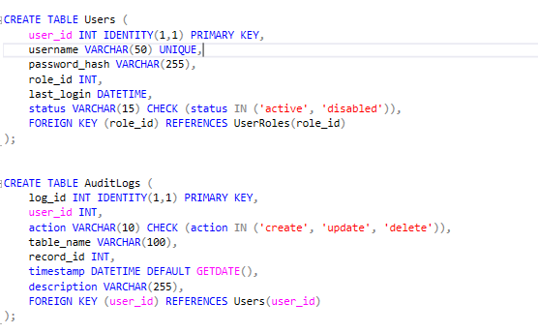

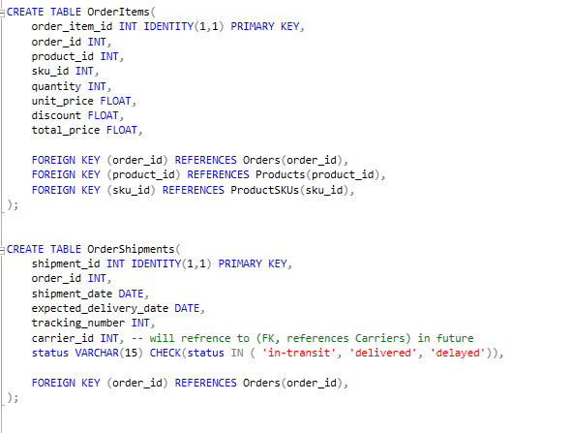

**Insert Data Queries:**

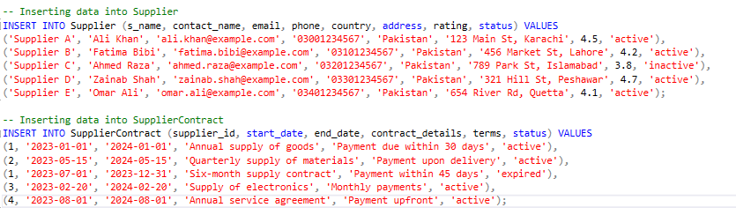

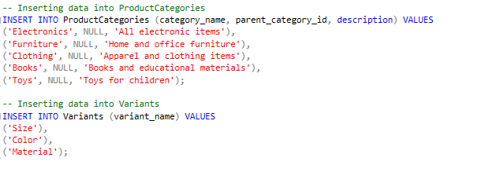

**Conclusion:**

This project aims to address the complexities of global supply chain management by providing a comprehensive, secure, and scalable database system. The system will support efficient operations, reduce lead times, and optimize costs, providing critical insights into supply chain performance.